LAB 6
Task 1:
SELECT
f.flight_id,
f.sch_departure_time,
f.sch_arrival_time,
f.departing_airport_id,
f.arriving_airport_id,
f.departing_gate,
f.arriving_gate,
a.airline_code,
a.airline_name,
f.act_departure_time,
f.act_arrival_time,
f.country
FROM flights f
INNER JOIN airlines a ON f.airline_id = a.airline_id
WHERE f.airline_id = 1;
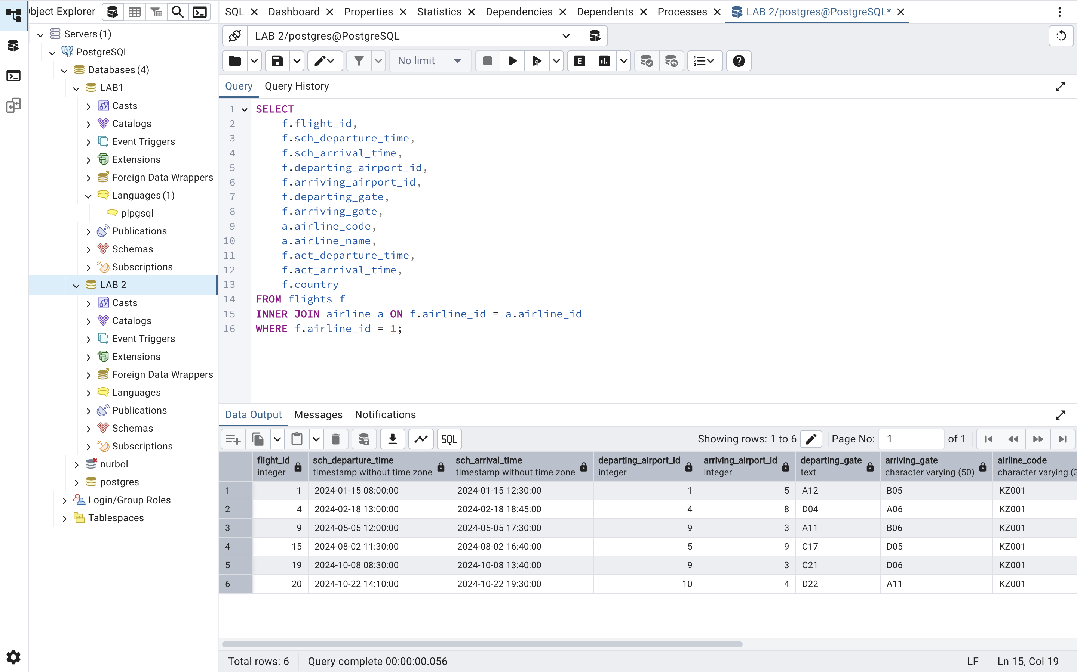
Task 2:
SELECT
f.flight_id,
TO_CHAR(f.sch_departure_time, 'YYYY-MM-DD HH24:MI') AS sch_departure,
TO_CHAR(f.sch_arrival_time, 'YYYY-MM-DD HH24:MI') AS sch_arrival,
dep_air.airport_name AS departure_airport_name,
arr_air.airport_name AS arrival_airport_name,
f.departing_gate,
f.arriving_gate,
al.airline_name,
TO_CHAR(f.act_departure_time, 'YYYY-MM-DD HH24:MI') AS act_departure,
TO_CHAR(f.act_arrival_time, 'YYYY-MM-DD HH24:MI') AS act_arrival
FROM flights f
INNER JOIN airports dep_air ON f.departing_airport_id = dep_air.airport_id
INNER JOIN airports arr_air ON f.arriving_airport_id = arr_air.airport_id
INNER JOIN airline al ON f.airline_id = al.airline_id
ORDER BY f.sch_departure_time;
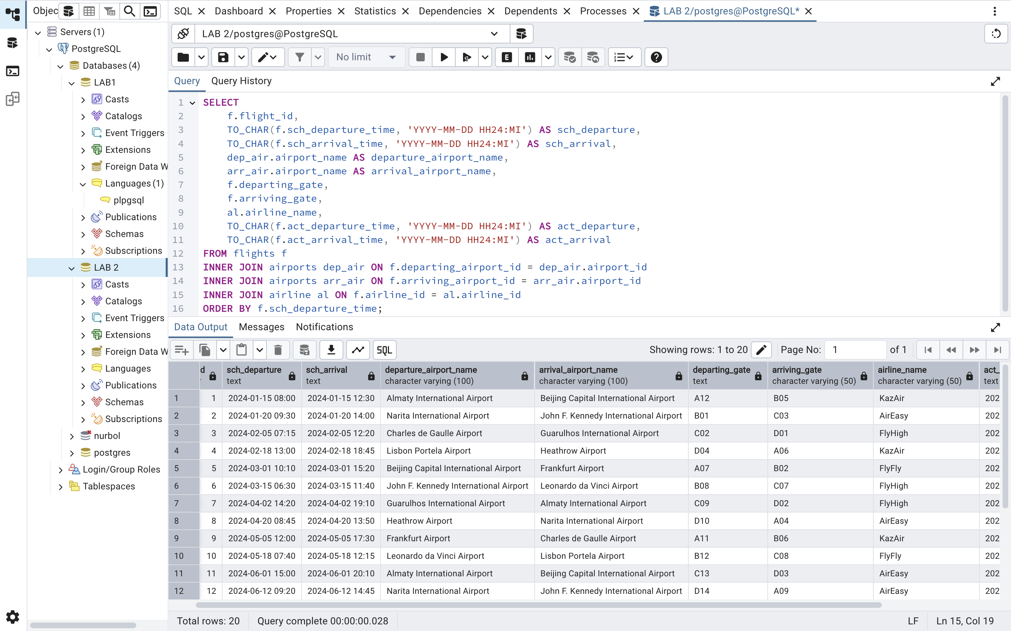
Task 3:
SELECT
a.airline_id,
a.airline_code,
a.airline_name,
a.airline_country,
COUNT(f_all.flight_id) AS total_flights,
MAX(f_all.sch_departure_time) AS last_scheduled_flight
FROM airline a
LEFT JOIN flights f ON a.airline_id = f.airline_id
AND f.sch_departure_time >= CURRENT_DATE
AND f.sch_departure_time < CURRENT_DATE + INTERVAL '1 month'
LEFT JOIN flights f_all ON a.airline_id = f_all.airline_id
WHERE f.flight_id IS NULL
GROUP BY
a.airline_id,
a.airline_code,
a.airline_name,
a.airline_country
ORDER BY a.airline_name;
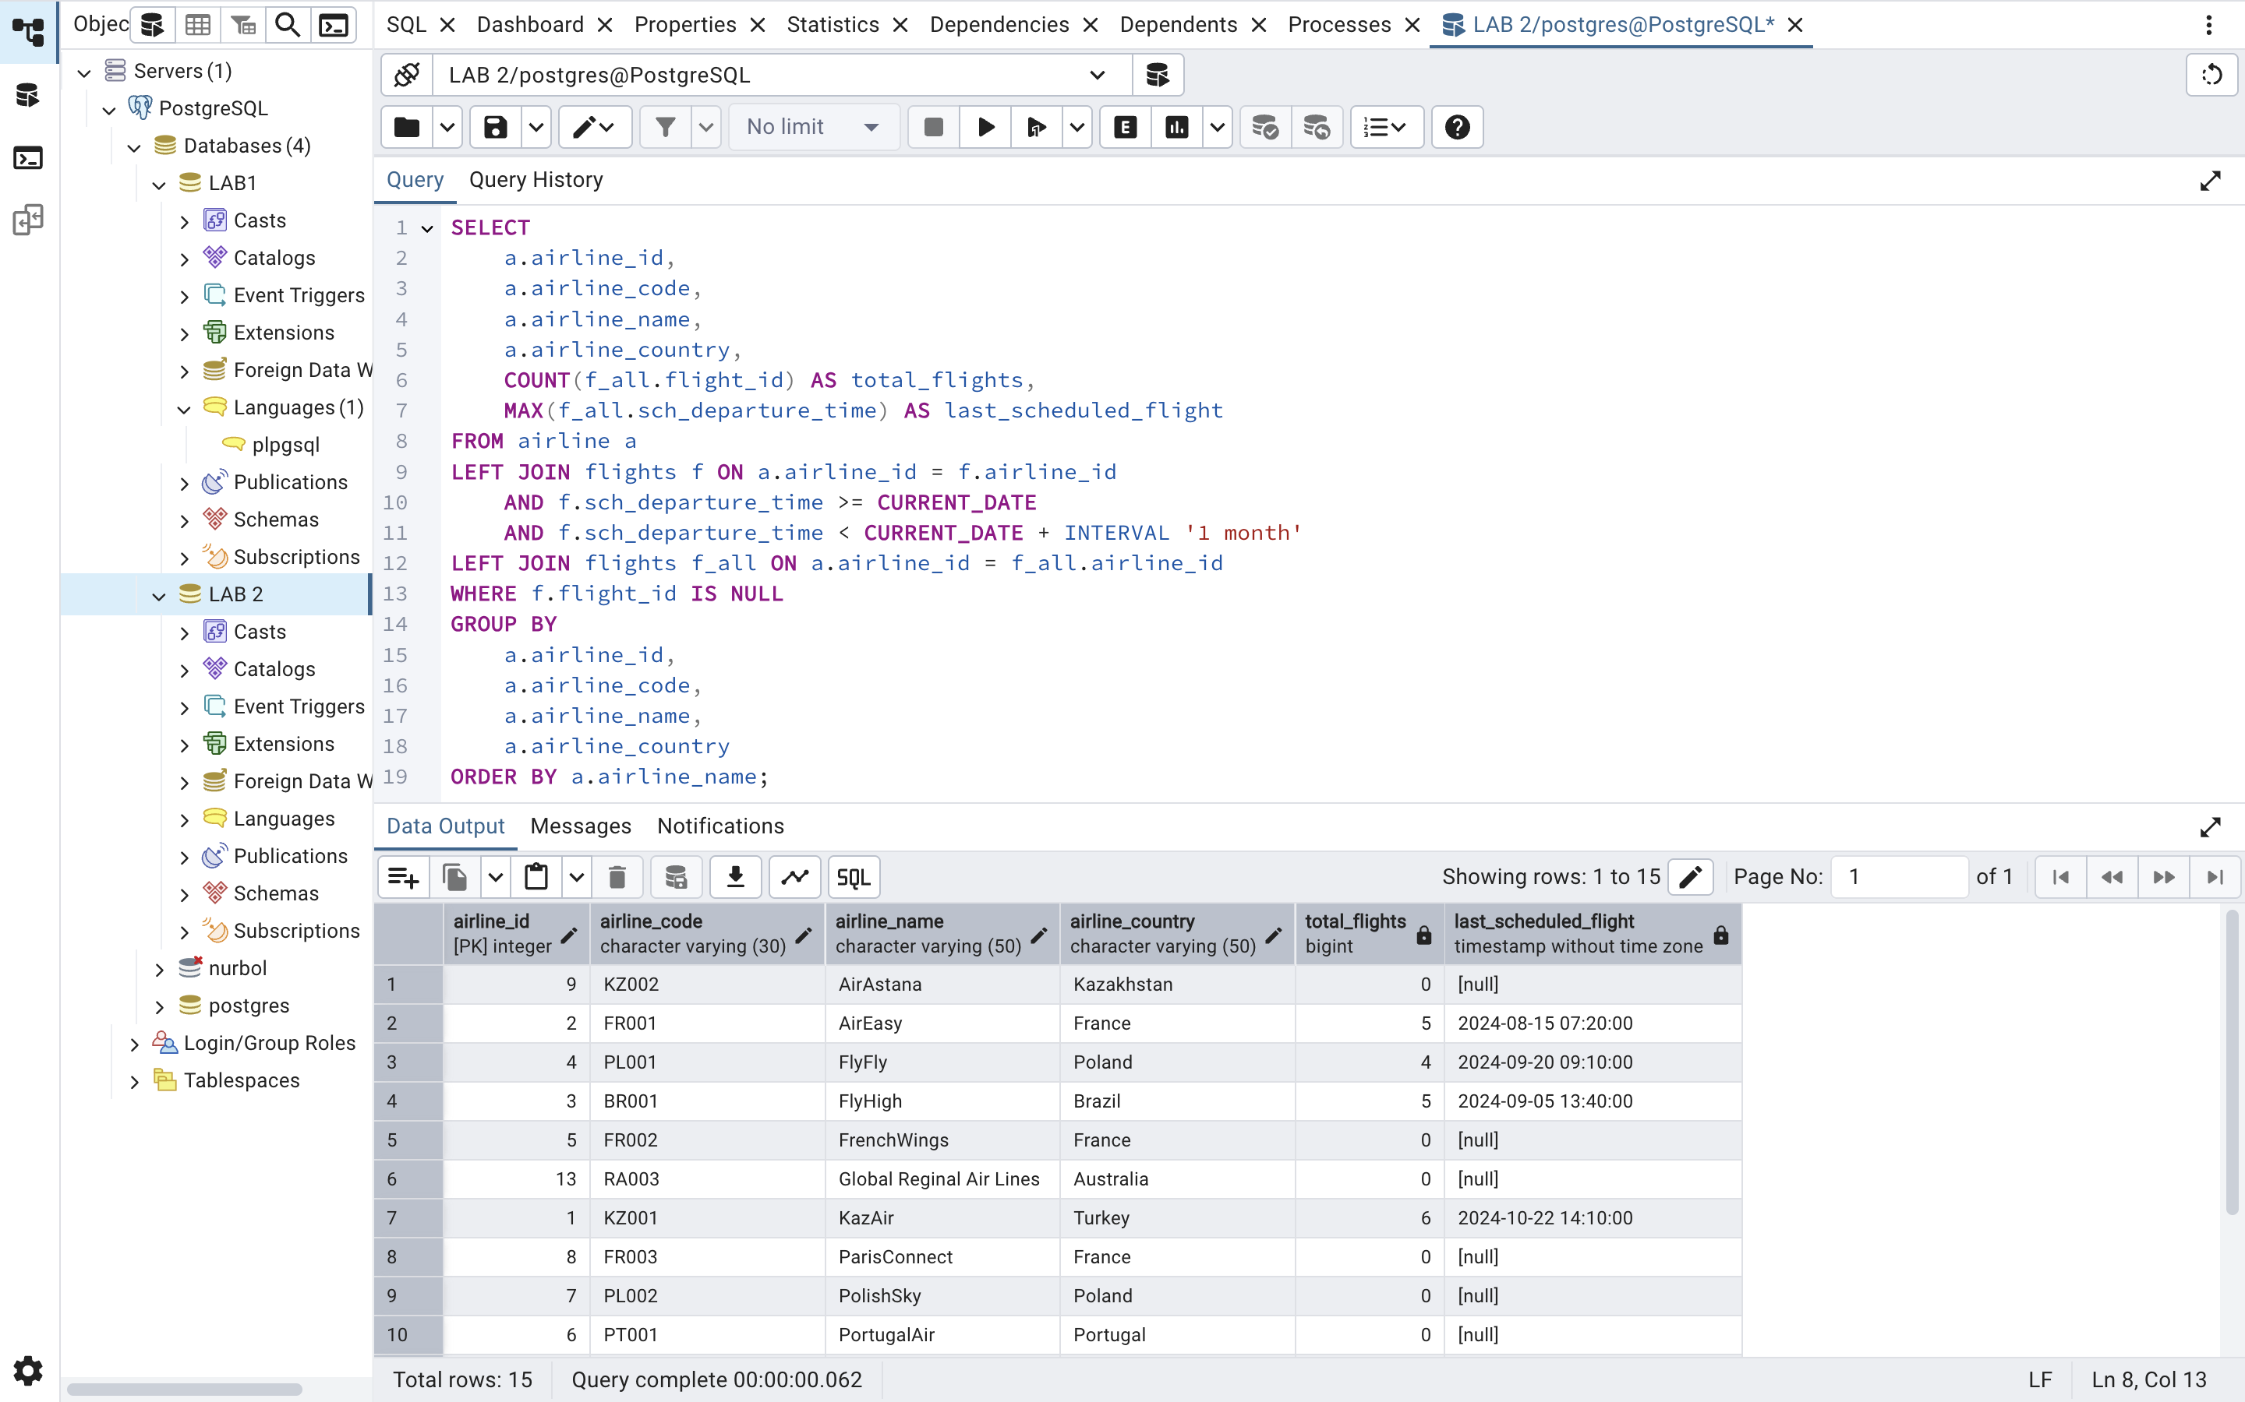
Task 4:
SELECT p.first_name, p.last_name, p.passenger_id FROM passengers p JOIN tickets t ON p.passenger_id = t.passenger_id WHERE t.flight_number = 'SU1001';
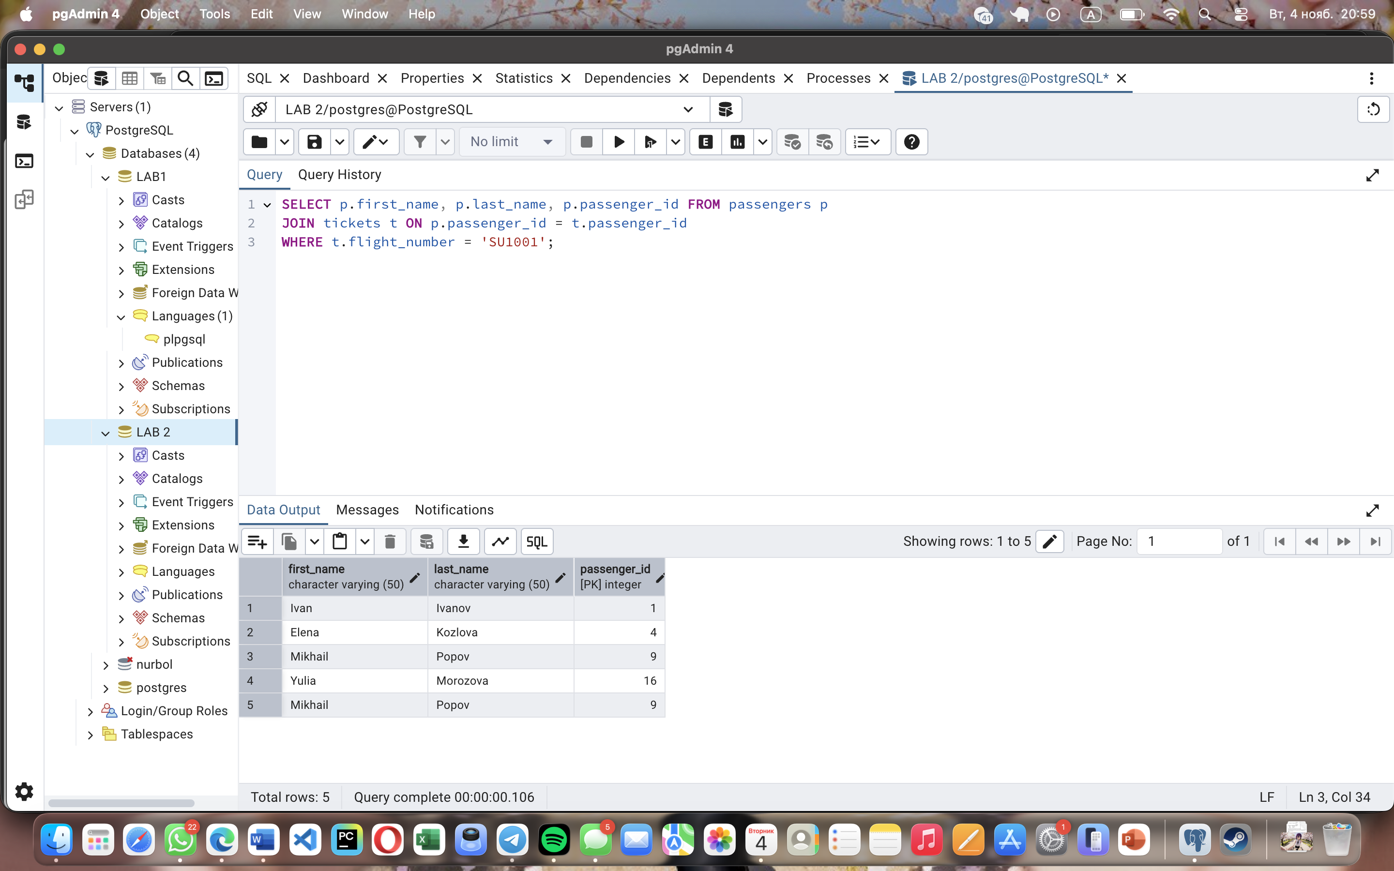
Task 5:
SELECT flight_number, AVG(price) as Average_price, MAX(price) as Maximum_price, MIN(price) as Minimum_price, SUM(price) as Total_price FROM tickets GROUP BY flight_number;
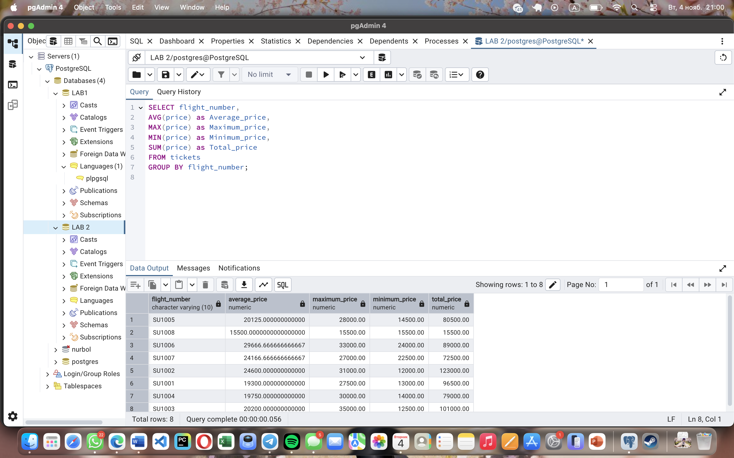
Task 6:
SELECT f.flight_id , a.airline_name , dep.airport_name , arr.airport_name, arr.country FROM flights f JOIN airline a ON f.airline_id = a.airline_id JOIN airport dep ON f.departing_airport_id = dep.airport_id JOIN airport arr ON f.arriving_airport_id = arr.airport_id WHERE arr.country = 'Kazakhstan';
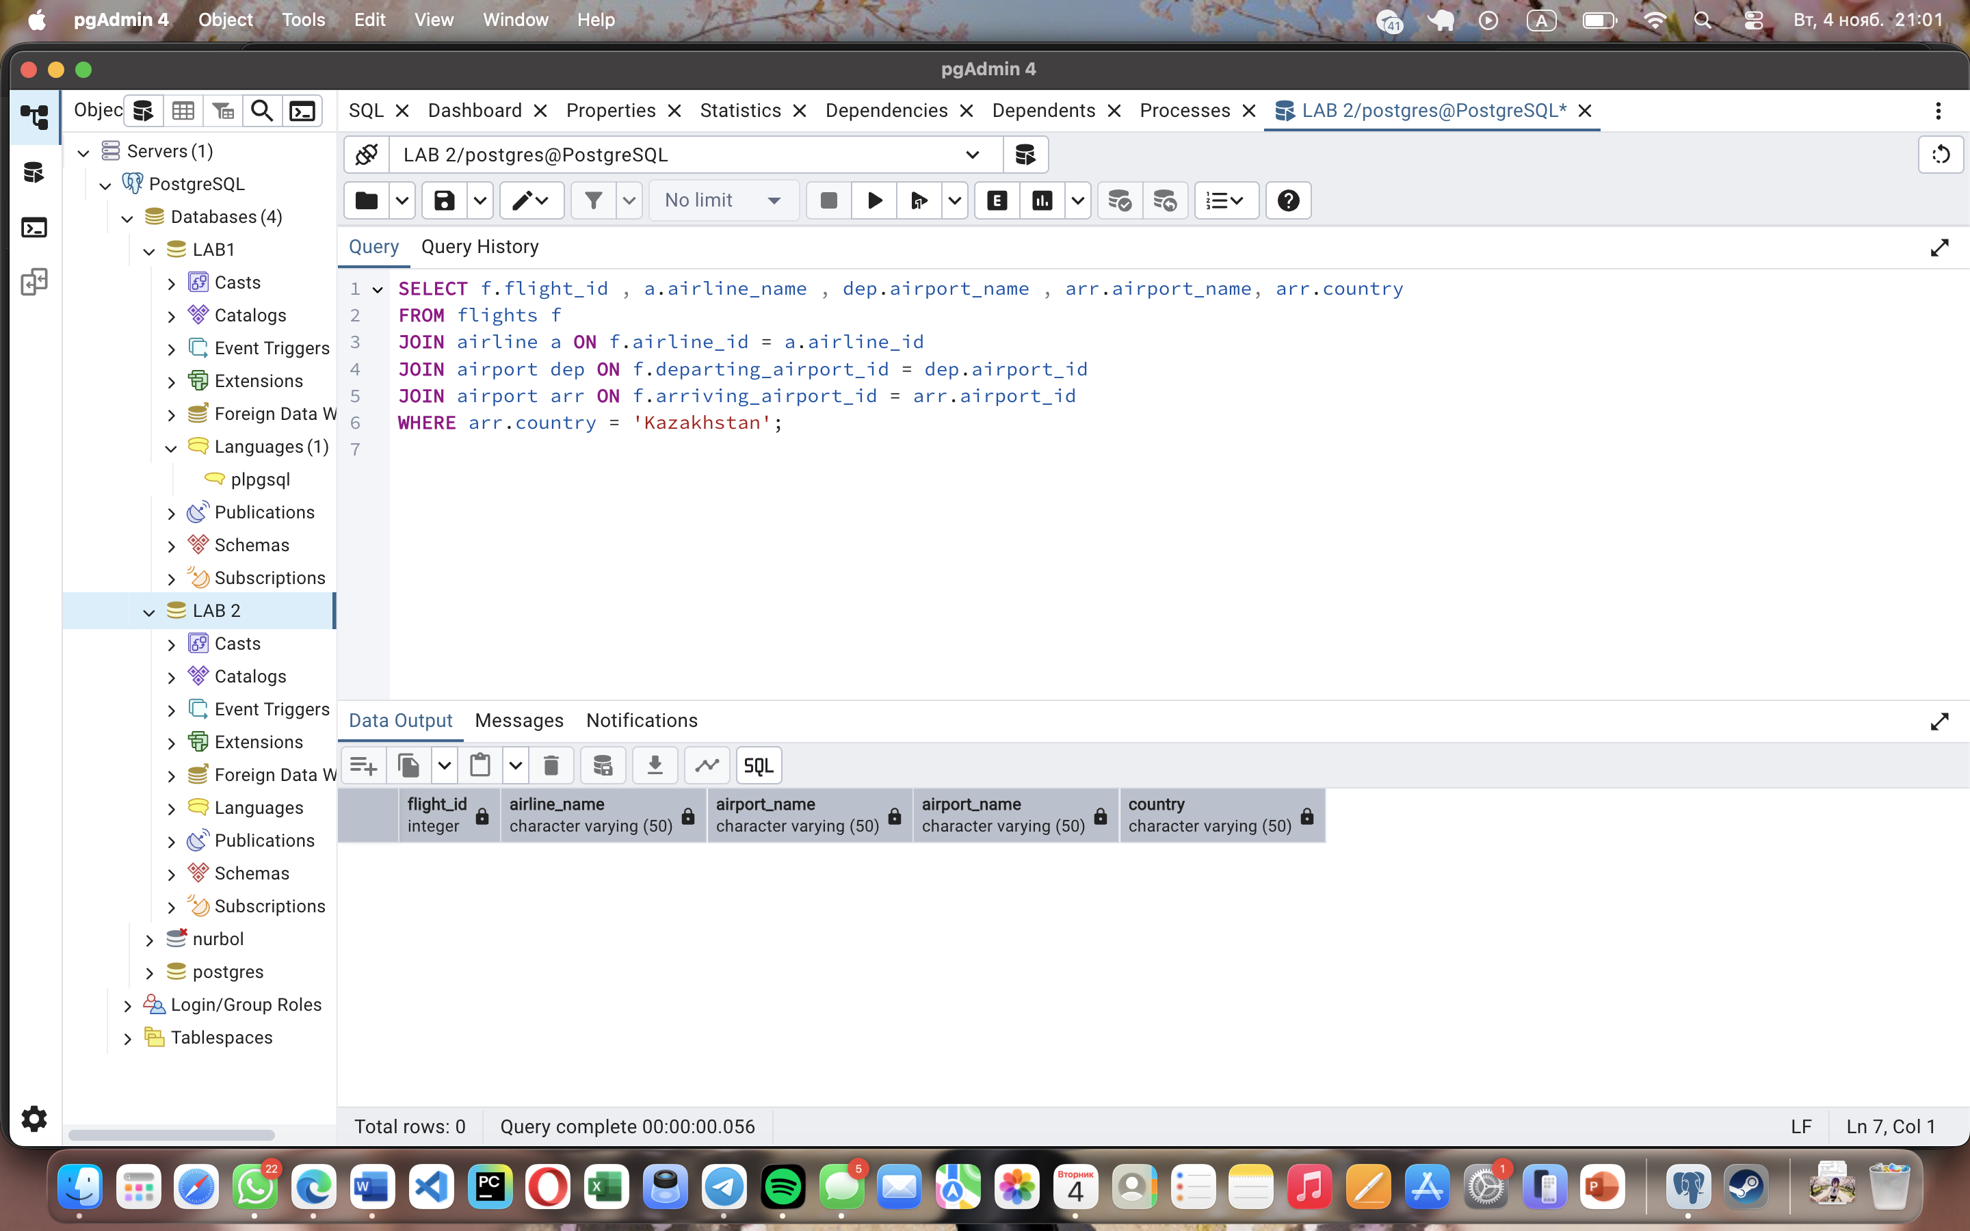
Task 7:
SELECT p.first_name, p.last_name, arr.city AS arrival_city FROM passengers p JOIN tickets t ON p.passenger_id = t.passenger_id JOIN booking b ON t.passenger_id = b.passenger_id JOIN booking_flight bf ON b.booking_id = bf.booking_id JOIN flights f ON bf.flight_id = f.flight_id JOIN airport arr ON f.arriving_airport_id = arr.airport_id WHERE AGE(p.date_of_birth) < INTERVAL '18 years';

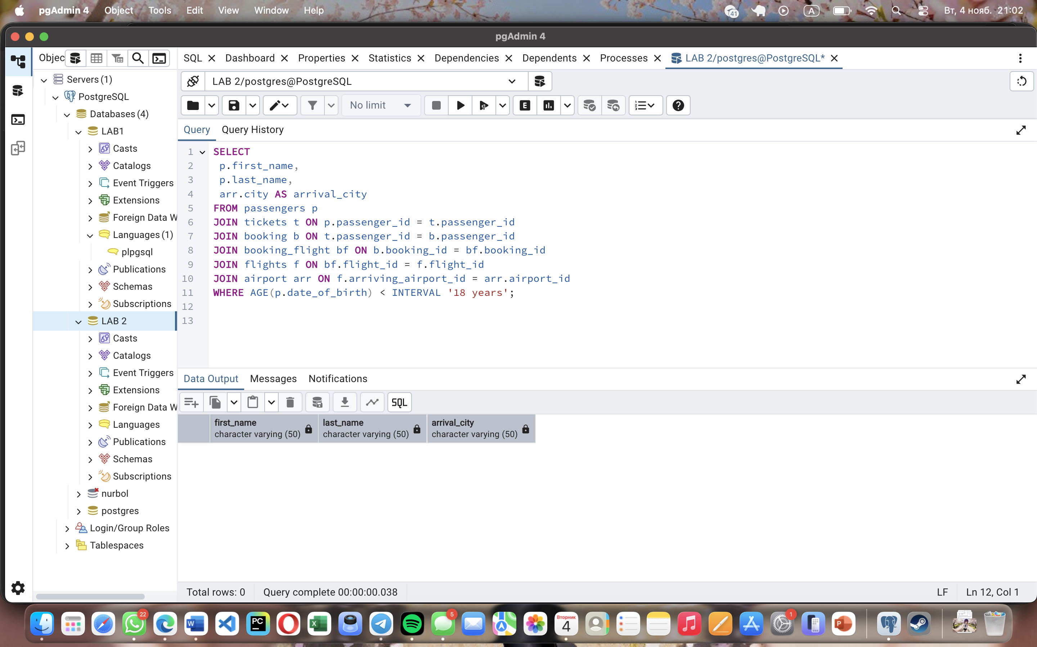
Task 8:
SELECT p.first_name ,p.last_name, p.passport_number, f.sch_arrival_time FROM passengers p JOIN tickets t ON p.passenger_id = t.passenger_id JOIN booking b ON t.passenger_id = b.passenger_id JOIN booking_flight bf ON b.booking_id = bf.booking_id JOIN flights f ON bf.flight_id = f.flight_id;
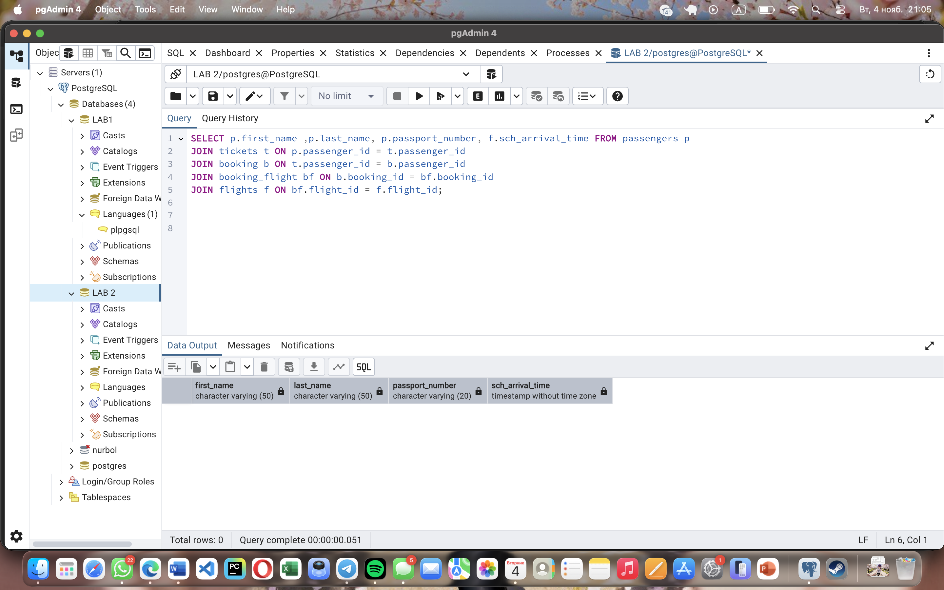
Task 9:
SELECT f.flight_id, a.airline_name, dep.country FROM flights f JOIN airline a ON f.airline_id = a.airline_id JOIN airport dep ON f.departing_airport_id = dep.airport_id WHERE a.airline_country = dep.country GROUP BY f.flight_id, a.airline_name, dep.country;
